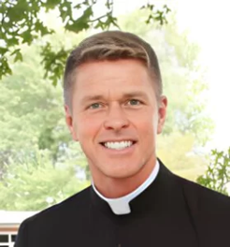
Fr. Jim Deiters
Pastor, St. Clare of Assisi Parish, O’Fallon, IL

Fr. Jim Deiters has a bachelor’s degree in business administration from the University of St. Thomas in St. Paul, Minnesota and a Master of Divinity from Mundelein Seminary in Chicago. Ordained in 1991, he has been pastor of St. Clare of Assisi Parish and School since 1996.
In addition to his primary role as pastor he also serves in the diocese as a consultant to the bishop and on the Mission and Planning Commission. On a national level, he served 12 years on the board of NOCERCC, for the ongoing formation of priests in the United States.
Fr. Deiters presently serves on the Board for Dynamic Catholic in Hebron, KY, and on the Board of Directors for Hospital Sisters Health System (HSHS), in Springfield, IL. He serves as an adjunct faculty for the "Institute of Priests and Presbyterates" at St. Meinrad Seminary. Publications include several videos and articles on the sacraments for Liguori Publications.

